IT5512- WEB TECHNOLOGY LAB-SESSION-1
DATE: 06/09/2021 FN
NAME: A.S. PRUTHIEV
REG NO.2019506067
ARRAY AND LIST JAVA PROGRAMS
1) AIM:
To write a Array and List Java code for the calculation of student details like adding a student, search a student with his/her name,Find the student with maximum cgpa , Find the student with minimum cgpa,Sort the student by name,Sort the student by cgpa.
.
1)
AIM:
To Write a java program perform various operations in student class using List interface in Collection library.

PROGRAM CODE:

package Java.Lab.lab2;
import java.util.*;
class Student{
private String name,rollNumber;
int curSem,age;
double cgpa;
public Student(String name, String rollNumber, int curSem, int age, double cgpa) {
this.name = name;
this.rollNumber = rollNumber;
this.curSem = curSem;
this.age = age;
this.cgpa = cgpa;
}
public String getName() {
return name;
}
public String getRollNumber() {
return rollNumber;
}
public int getCurSem() {
return curSem;
}
public int getAge() {
return age;
}
public boolean isNull(){
return false;
}
public double getCgpa() {
return cgpa;
}
@Override
public String toString() {
return name + " " + rollNumber + " " + age + " " + cgpa + " " + curSem;
}
}
public class ListArray {
private static Scanner input = new Scanner(System.in);
public static void add(ArrayList<Student>students){
int age,curSem;
String name,rollNumber;
double cgpa;
input.nextLine();
System.out.print("Enter name :");
name = input.nextLine();
System.out.print("Enter roll number :");
rollNumber = input.nextLine();
System.out.print("Enter age , current Semester, and cgpa :");
age = input.nextInt();
curSem = input.nextInt();
cgpa = input.nextDouble();
students.add(new Student(name,rollNumber,curSem,age,cgpa));
}
public static void remove(ArrayList<Student>students){
input.nextLine();
String name;
System.out.print("Enter student name :");
name = input.nextLine();
if(students.removeIf(x -> x.getName().equals(name)))System.out.println("Student name removed successfully");
else System.out.println("Student name not exists");
}
public static void search(ArrayList<Student>students){
input.nextLine();
String name;
System.out.print("Enter student name :");
name = input.nextLine();
if((students.stream().filter(x -> x.getName().equals(name)).findAny().orElse(null) != null)){
System.out.println("Student exists");
}
else System.out.println("Student details not exists");
}
public static Student findMaxCGPA(ArrayList<Student>students){
double maxCgpa = students.stream().mapToDouble(Student::getCgpa).max().orElse(-1);
return students.stream().filter(x -> x.getCgpa() == maxCgpa).findAny().orElse(null);
}
public static Student findMinCGPA(ArrayList<Student>students){
double maxCgpa = students.stream().mapToDouble(Student::getCgpa).min().orElse(-1);
return students.stream().filter(x -> x.getCgpa() == maxCgpa).findAny().orElse(null);
}
public static void sortByName(ArrayList<Student>students){
students.sort(Comparator.comparing(Student::getName));
}
public static void sortByCGPA(ArrayList<Student>students){
students.sort(Comparator.comparing(Student :: getCgpa).reversed());
}
public static void main(String[] args) {
ArrayList<Student>students = new ArrayList<>();
int choice;
System.out.println("The choice are :");
System.out.println("1 --> Add Student\n2 --> Remove Student\n3 --> Search a Student\n4 --> Find Student with max CGPA" +
"\n5 --> Find Student with min CGPA\n6 --> Sort Students by name\n7 --> Sort students by CGPA\n8 --> Display Details\n");
do {
System.out.print("Enter the choice :");
choice = input.nextInt();
switch (choice) {
case 1 -> add(students);
case 2 -> remove(students);
case 3 -> search(students);
case 4 -> {
Student st = findMaxCGPA(students);
if (st != null) {
System.out.println(st);
}
}
case 5 -> {
Student st1 = findMinCGPA(students);
if (st1 != null) {
System.out.println(st1);
}
}
case 6 -> {
sortByName(students);
System.out.println(students);
}
case 7 -> {
sortByCGPA(students);
System.out.println(students);
}
case 8 -> {
System.out.println(students);
}
default -> System.out.println("Enter a valid choice !!!");
}
}while(choice >= 0);
}
}

OUTPUT:

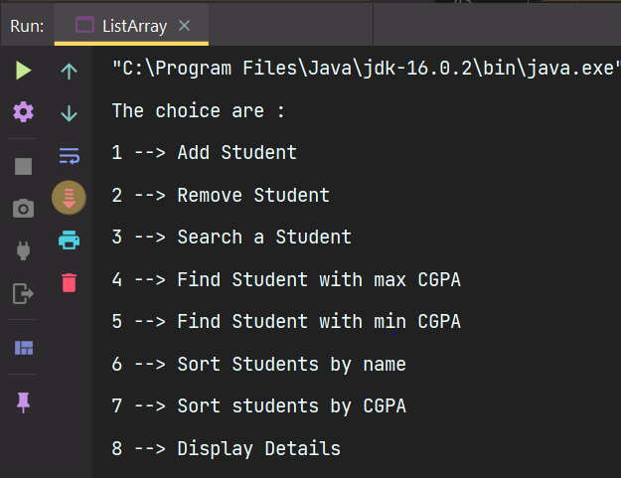
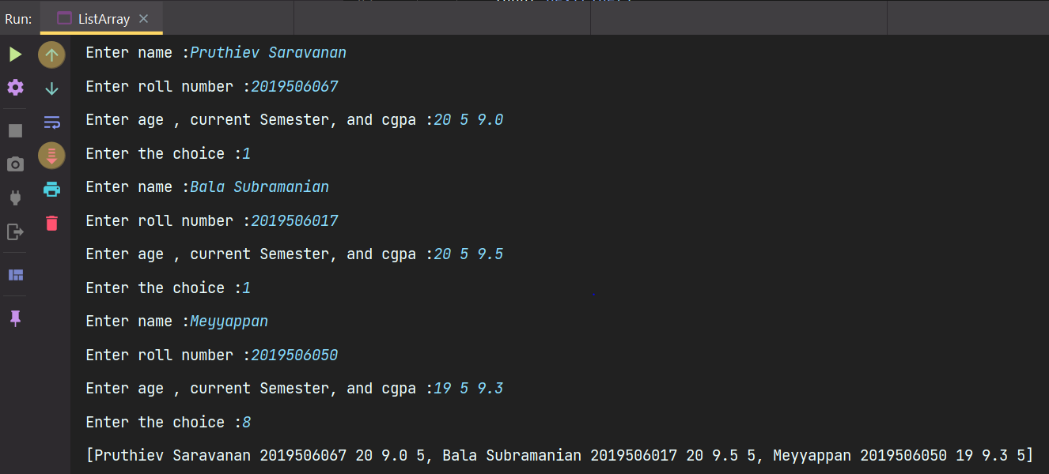
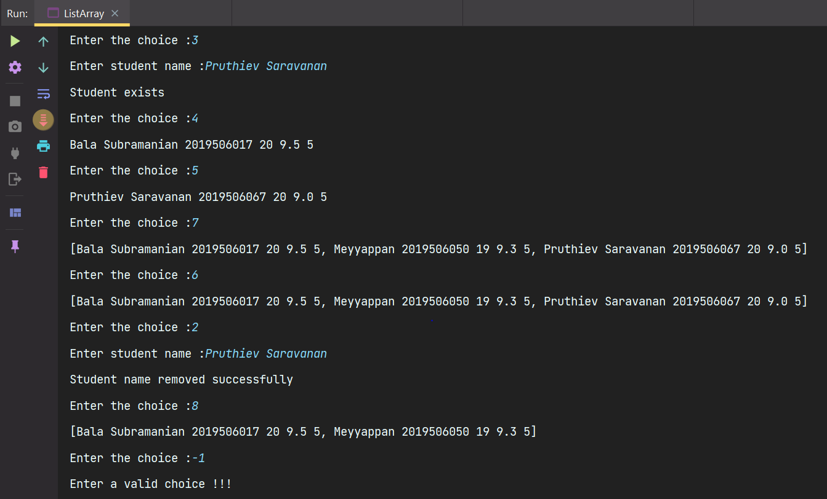

RESULT:
Thus, the program has been executed successfully.
1) b.
AIM:
To Write a java program perform various operations in student class using Array data type

PROGRAM CODE

package Java.Lab.lab2;

import java.util.*;

public class Array {
private static Scanner input = new Scanner(System.in);
static int count = 0;
public static void add(Student[]students){
int age,curSem;
String name,rollNumber;
double cgpa;
input.nextLine();
System.out.print("Enter name :");
name = input.nextLine();
System.out.print("Enter roll number :");
rollNumber = input.nextLine();
System.out.print("Enter age , current Semester, and cgpa :");
age = input.nextInt();
curSem = input.nextInt();
cgpa = input.nextDouble();
if(count >= students.length)System.out.println("Array is full ");
else students[count++] = new Student(name,rollNumber,curSem,age,cgpa);
}
public static void remove(Student[]students){
input.nextLine();
String name;
System.out.print("Enter student name :");
name = input.nextLine();
int index = -1;
for(int i = 0 ; i < students.length ; i++){
if(students[i].getName().equals(name)){
index = i;
break;
}
}
if(index != -1){
for(int i = index ; i < students.length-1 ; i++){
students[i] = students[i+1];
}
students[count-1] = null;
count --;
System.out.println("The student details are removed successfully");
}
else{
System.out.println("Student does not exists");
}

}
public static void search(Student[]students){
input.nextLine();
String name;
System.out.print("Enter student name :");
name = input.nextLine();
Student findStudent = Arrays.stream(students).filter(x -> (x.getName().equals(name))).findAny().orElse(null);
if(findStudent != null)System.out.println("The student detail exists");
else System.out.println("The student details does not exists");
}
public static Student findMaxCGPA(Student[]students){
return Arrays.stream(students).max(Comparator.comparing(Student :: getCgpa)).orElse(null);
}
public static Student findMinCGPA(Student[]students){
return Arrays.stream(students).min(Comparator.comparing(Student :: getCgpa)).orElse(null);
}
public static void sortByName(Student[]students){
Arrays.sort(students,Comparator.nullsLast(Comparator.comparing(Student ::getName)));
}
public static void sortByCGPA(Student[]students){
Arrays.sort(students,Comparator.nullsLast(Comparator.comparing(Student ::getCgpa).reversed()));
}
public static void main(String[] args) {
int n;
System.out.println("Enter the number of students :");
n = input.nextInt();
Student[]students = new Student[n];
int choice;
System.out.println("The choice are :");
System.out.println("1 --> Add Student\n2 --> Remove Student\n3 --> Search a Student\n4 --> Find Student with max CGPA" +
"\n5 --> Find Student with min CGPA\n6 --> Sort Students by name\n7 --> Sort students by CGPA\n8 --> Display Details\n");
do {
System.out.print("Enter the choice :");
choice = input.nextInt();
switch (choice) {
case 1 -> add(students);
case 2 -> remove(students);
case 3 -> search(students);
case 4 -> {
Student st = findMaxCGPA(students);
if (st != null) {
System.out.println(st.toString());
}
}
case 5 -> {
Student st1 = findMinCGPA(students);
if (st1 != null) {
System.out.println(st1.toString());
}
}
case 6 -> {
sortByName(students);
Arrays.stream(students).filter(Objects::nonNull).forEach((x) -> System.out.print(x.toString() + " , "));
System.out.println();
}
case 7 -> {
sortByCGPA(students);
Arrays.stream(students).filter(Objects::nonNull).forEach((x) -> System.out.print (x.toString() + " , "));
System.out.println();
}
case 8 -> {
Arrays.stream(students).filter(Objects::nonNull).forEach((x) -> System.out.print(x.toString() + " , "));
System.out.println();
}
default -> System.out.println("Enter a valid choice !!!");
}
}while(choice >= 0);
}

}

OUTPUT:

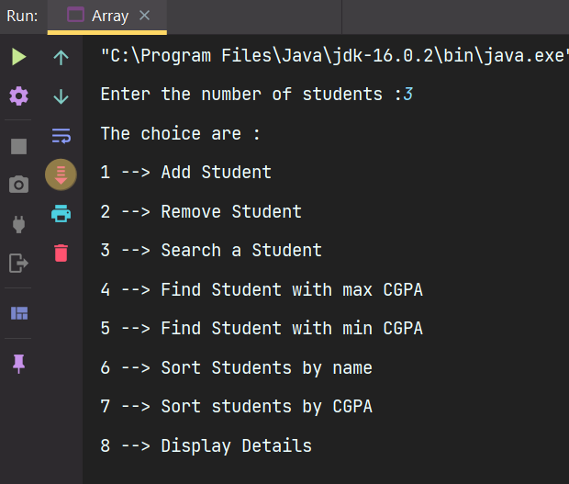

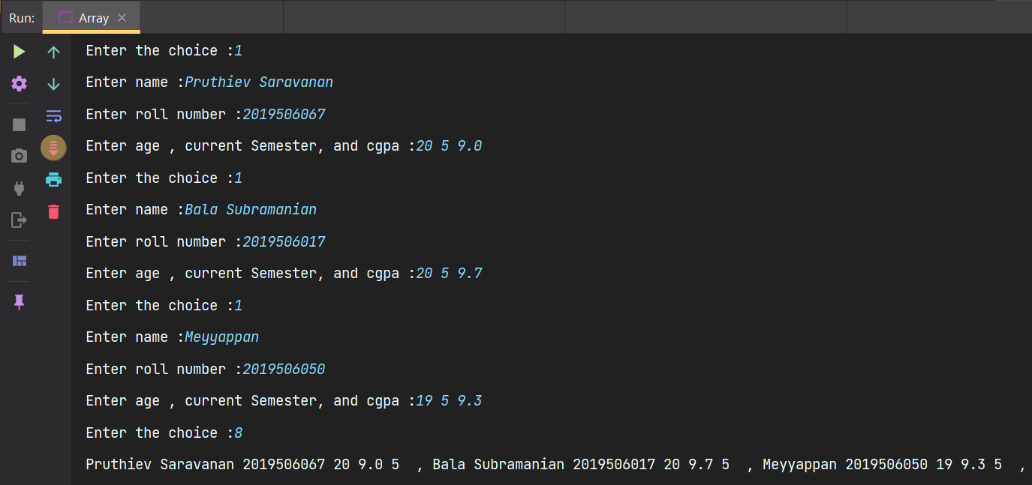

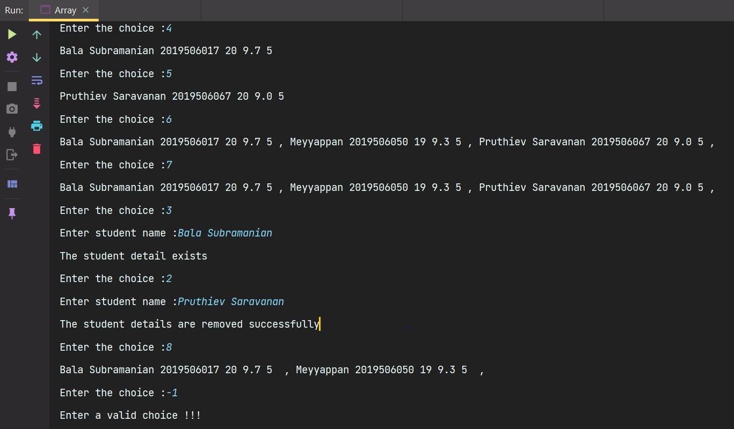

RESULT:
Thus, the program has been executed successfully.
LIST (Collection Library) vs Array(Data type)

LIST | ARRAY
- A list is an interface that extends from collection interface  - It can only store homogeneous elements at any instant of time  - No need of specifying the size before it can resize and add elements dynamically  - It has in-built methods like add , remove,search,isEmpty etc.  - Since it is interface the memory is allocated on heap.  - It can only store non-primitives  - We can traverse the array using ,forEach and iterator as List provide the support of iterators as they implemt the iterable interface.  - We can convert the List to array using toArray methods defined in the Collections class.  - We can perform in-built operations using the interface as well as using the Collections class.  - The syntax and data type to be mentioned is  List<DataType>l = new ArrayList<>(); | - An array is a in-built data type which extends from Object class  - It too can only store homogeneous collection of elements  - The size of the array has to be specified before adding elements to it.  - No built in menthods as such each and everything has to implemented by the programmer who uses array  - Since it is a class it is allocated in heap  - It can store both primitive anhd non primitive data types  - We can traverse using for and enchaned for loop as ther is no support for iterators  - We can convert array to List using Arrays.asList() method defined in the Arrays class.  - We can perform in-built operations only using Arrays class.  - The syntax and data type to mentioned is as follows  DataType arr[] = new DataType[size];

RESULT:
Thus, the program has been executed successfully.
1) d.
AIM:
To Write a java program to find a factorial of a number.

PROGRAM CODE:

package Java.Lab.lab1;

import java.util.Scanner;

public class Factorial {
private static Scanner input = new Scanner(System.in);
public static long getFactorial(int num){
long ans = 1;
for(int i =2 ; i <= num ; i++){
ans *= i;
}
return ans;
}
public static void main(String[] args) {
int n;
System.out.print("Enter a number :");
n = input.nextInt();
System.out.print("The factorial of the numnber " + n +" is :" + getFactorial(n));
}
}

OUTPUT:

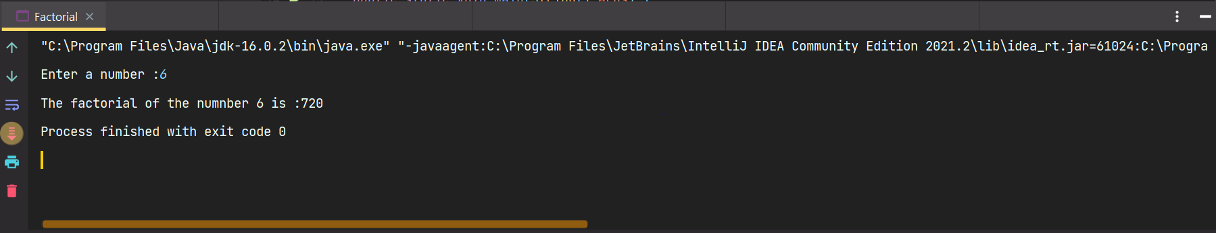

RESULT:
Thus, the program has been executed successfully.
1) e.
AIM:
To write a program to find sum of all integers greater than 100 and less than 200 that are divisible by 4

PROGRAM CODE:

package Java.Lab.lab1;

public class SumNum {
public static void main(String[] args) {
int sum = 0;
for(int i = 100 ; i < 200 ; i++){
if(i % 4 == 0)sum += i;
}
System.out.print("The sum of the numbers >= 100 and < 200 is :" + sum);
}
}

OUTPUT:

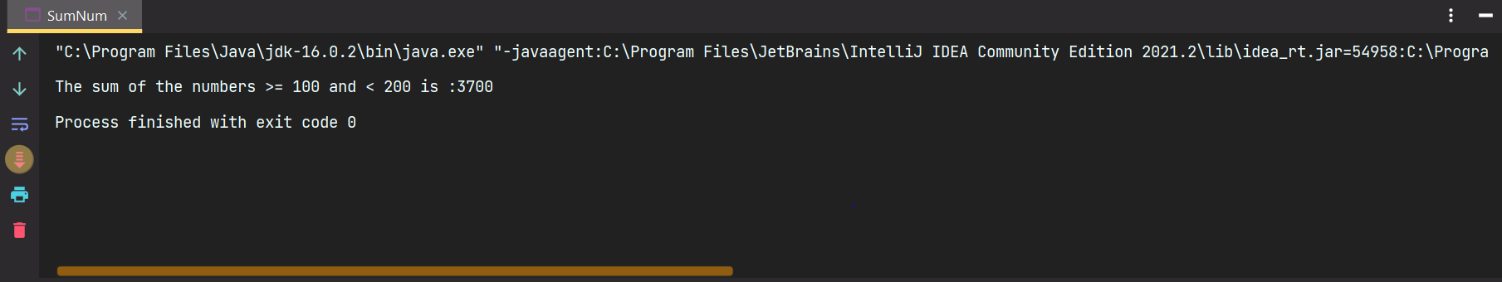

RESULT:
Thus, the program has been executed successfully.
1) f.
AIM:
To Write a program to print even numbers between 1 to 200

PROGRAM CODE:

package Java.Lab.lab1;

public class PrintEven {
public static void main(String[] args) {
System.out.println("The even numbers between 1 and 200 are as follows :");
for(int i = 1 ; i <= 200 ; i++){
if(i % 50 == 0)System.out.println();
if(i % 2 == 0)System.out.print(i + " ");

}
}
}

OUTPUT:

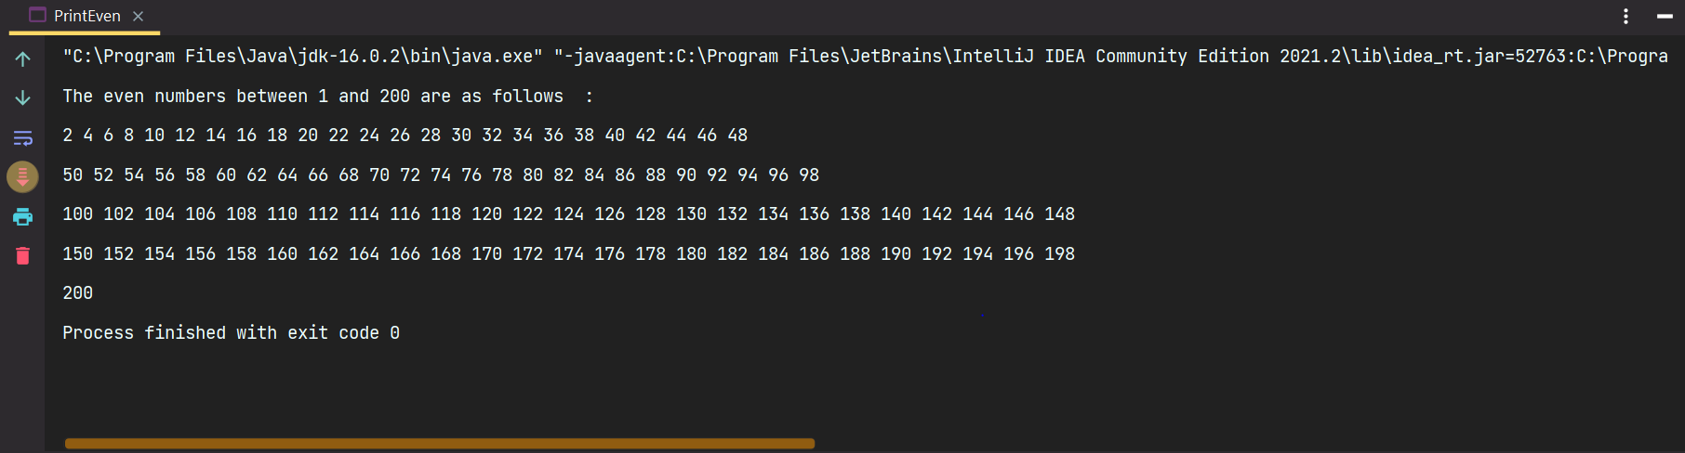

RESULT:
Thus, the program has been executed successfully.
1) g.
AIM:
To Write a program to check whether a number is positive or negative

PROGRAM CODE:

package Java.Lab.lab1;

import java.util.Scanner;

public class PosNegnumber {
private static Scanner input = new Scanner(System.in);
public static void main(String[] args) {
int n;
n = input.nextInt();
if(n >=0 )System.out.print("The number is positive");
else System.out.print("The number is negative");
}
}

OUTPUT:

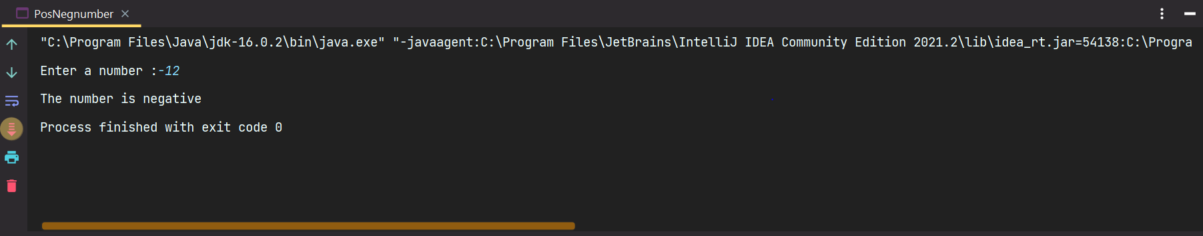

RESULT:
Thus, the program has been executed successfully.

1)h.
AIM:
To Write a program to display the student details.

PROGRAM CODE:

package Java.Lab.lab1;

import java.util.Scanner;

class StudentDetails{
private final static Scanner input = new Scanner(System.in);
private int age;
private String name,phoneNumber,rollNumber;
private int []marks;
private int numberOfSubjects;
private double cgpa;
StudentDetails(int age, String name, String phoneNumber, String rollNumber,int numberOfSubjects ) {
this.age = age;
this.name = name;
this.phoneNumber = phoneNumber;
this.rollNumber = rollNumber;
this.numberOfSubjects = numberOfSubjects;
marks = new int[numberOfSubjects];
System.out.print("Enter subject marks :");
for(int i = 0 ; i < numberOfSubjects ; i++){
marks[i] = input.nextInt();
}
input.nextLine();
}
public int getAge() {
return age;
}
public String getName() {
return name;
}
public String getPhoneNumber() {
return phoneNumber;
}
public String getRollNumber() {
return rollNumber;
}
public double getCgpa() {
return cgpa;
}
void calculateCGPA(){
double total = 0d;
for(int i = 0 ; i < marks.length ; i++)total += marks[i];
cgpa = total / (double)numberOfSubjects;
}
}
public class Student {
private final static Scanner input = new Scanner(System.in);
public static void main(String[] args) {
int n;
int age;
String name,phoneNumber,rollNumber;
int numberOfSubjects;
System.out.print("Enter the number of students :");
n = input.nextInt();;
StudentDetails [] students = new StudentDetails[n];
for(int i = 0 ; i < n ; i++){
input.nextLine();
System.out.print("Enter the name : ");
name = input.nextLine();
System.out.print("Enter the age :");
age = input.nextInt();
input.nextLine();
System.out.print("Enter the phone Number :");
phoneNumber = input.nextLine();
System.out.print("Enter the roll number :");
rollNumber = input.nextLine();
System.out.print("Enter the number of subjects :");
numberOfSubjects = input.nextInt();
students[i]=new StudentDetails(age,name,phoneNumber,rollNumber,numberOfSubjects);
students[i].calculateCGPA();
}
for(int i = 0 ; i < n ; i++){
System.out.println("The name is :" + students[i].getName());
System.out.println("The age is :" + students[i].getAge());
System.out.println("The roll number is :" + students[i].getRollNumber());
System.out.println("The phone number is :" + students[i].getPhoneNumber());
System.out.printf("The CGPA is : %.2f" + students[i].getCgpa());
}
}
}

OUTPUT:
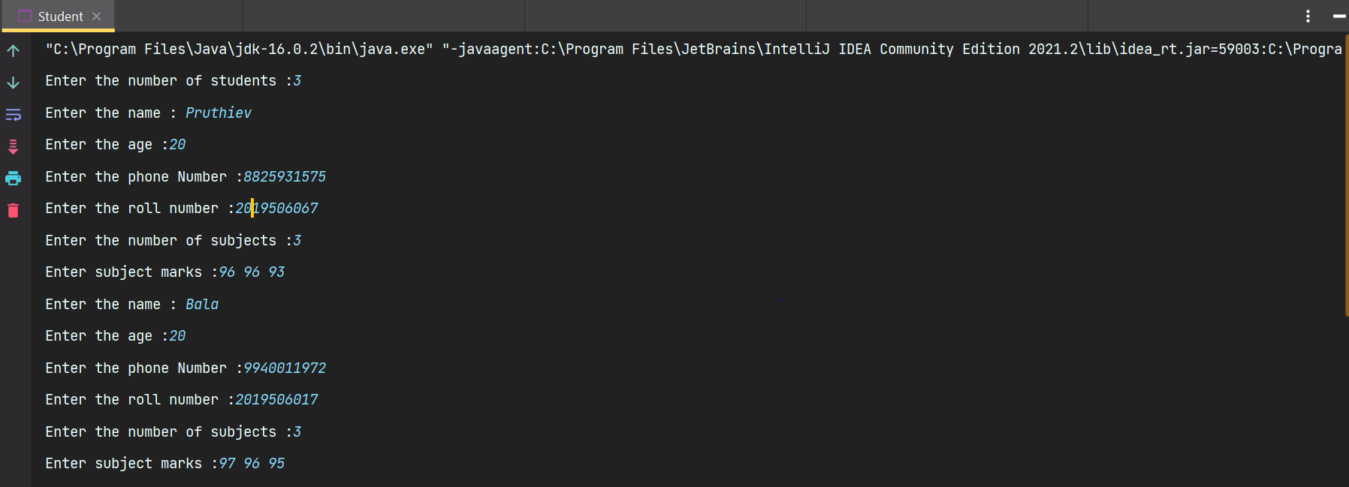

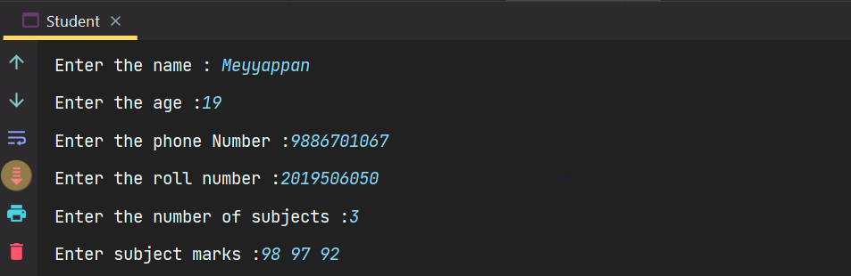

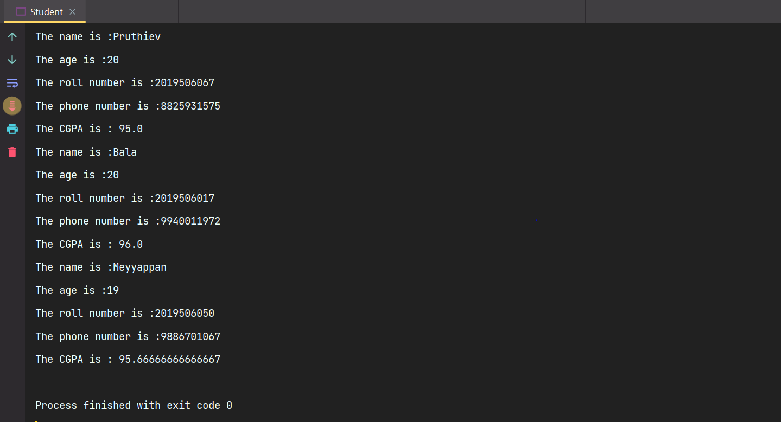

RESULT:
Thus, the program has been executed successfully.

